DSA using C practical files
25/SCA/BCAC/030
1)
#include <stdio.h>

int main() {
int i,n,pos,elm,choice;

printf("Enter the size of the array: ");
scanf("%d",&n);

int arr[n];

printf("Enter the elements of the array:\n");
for (i=0; i<n; i++) {
printf("arr[%d]:", i);
scanf("%d",&arr[i]);
}

do {
printf("\n--- MENU ---\n");
printf("1. Insertion\n");
printf("2. Deletion\n");
printf("3. Display\n");
printf("4. Exit\n");
printf("Enter your choice: ");
scanf("%d",&choice);

switch (choice){

case 1:
printf("Enter the element you want to insert: ");
scanf("%d",&elm);

printf("Enter the position : ",n);
scanf("%d",&pos);

for (i=n;i>pos;i--) {
arr[i] =arr[i - 1];
}

arr[pos]=elm;
n++;
printf("Element inserted successfully.\n");
break;

case 2:
printf("Enter the position to delete: ", n);
scanf("%d", &pos);
for (i=pos;i<n-1;i++) {
arr[i]=arr[i+1];
}

n--;
printf("Element deleted successfully.\n");
break;

case 3:
printf("Array elements are:\n");
for (i = 0; i<n;i++) {
printf("%d ",arr[i]);
}
printf("\n");

break;

case 4:
printf("Exiting program\n");
break;

default:
printf("Invalid choice!\n");
}

} while (choice != 4);

return 0;
}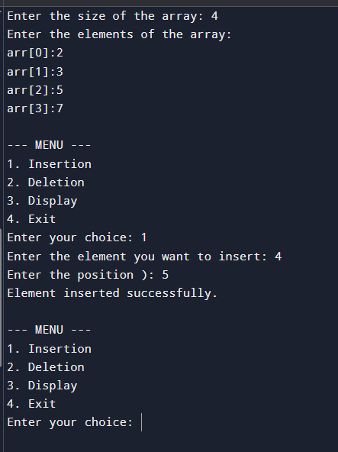
2)
// Online C compiler to run C program online
#include <stdio.h>

int main() {
int choice, i, j, k;
int m1[3][3],m2[3][3],result[3][3];
printf("\nEnter elements of Matrix 1:\n");
for (i=0; i<3;i++){
for (j=0;j<3;j++){
printf("m1[%d][%d]:",i+1,j+1);
scanf("%d",&m1[i][j]);
}
}

printf("\nEnter elements of Matrix 2:\n");
for (i = 0; i < 3; i++){
for (j = 0; j < 3; j++){
printf("m2[%d][%d]:",i+1,j+1);
scanf("%d", &m2[i][j]);
}
}
do {
printf("\n--- MENU (3x3 MATRIX) ---\n");
printf("1. Addition\n");
printf("2. Subtraction\n");
printf("3. Multiplication\n");
printf("4. Exit\n");
printf("Enter your choice: ");
scanf("%d", &choice);

switch (choice) {

case 1:
for (i=0;i<3;i++)
for (j=0;j<3;j++)
result[i][j]=m1[i][j]+m2[i][j];
printf("\nResult of Addition:\n");
break;

case 2:
for (i=0;i<3;i++)
for (j=0;j<3;j++)
result[i][j] = m1[i][j] - m2[i][j];

printf("\nResult of Subtraction:\n");
break;

case 3:
for (i=0;i<3;i++) {
for (j=0;j<3;j++) {
result[i][j]=0;
for (k=0;k<3;k++) {
result[i][j] += m1[i][k]*m2[k][j];
}
}
}

printf("\nResult of Multiplication:\n");
break;

case 4:
printf("Exiting program...\n");
break;

default:
printf("Invalid choice!\n");
}

if (choice >= 1 && choice <= 3) {
for (i = 0; i < 3; i++) {
for (j = 0; j < 3; j++) {
printf("%d ", result[i][j]);
}
printf("\n");
}
}

} while (choice != 4);

return 0;
}
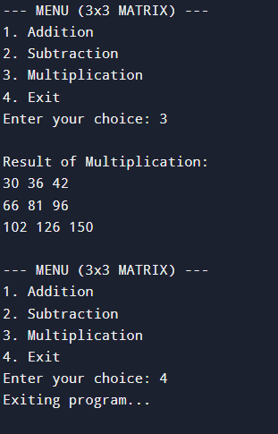
3)
#include <stdio.h>

int a[50], n;

void display() {
int i;
printf("Sorted Array: ");
for(i=0;i<n;i++)
printf("%d ",a[i]);
printf("\n");
}

void bubble() {
int i,j,temp;
for(i=0;i<n-1;i++) {
for(j=0;j<n-i-1;j++) {
if(a[j] > a[j+1]) {
temp=a[j];
a[j]=a[j+1];
a[j+1]=temp;
}
}
}
}

void insertion() {
int i,j,key;
for(i=1;i<n;i++) {
key=a[i];
j=i-1;
while(j>=0 && a[j]>key) {
a[j+1]=a[j];
j--;
}
a[j+1]=key;
}
}

void quick(int low,int high) {
int i=low,j=high,pivot,temp;
pivot=a[low];

while(i<j) {
while(a[i]<=pivot && i<high)
i++;
while(a[j]>pivot)
j--;
if(i<j) {
temp=a[i];
a[i]=a[j];
a[j]=temp;
}
}

temp=a[low];
a[low]=a[j];
a[j]=temp;

if(low<j-1)
quick(low,j-1);
if(j+1<high)
quick(j+1,high);
}

void merge(int l,int m,int r) {
int i=l,j=m+1,k=l,temp[50];

while(i<=m && j<=r) {
if(a[i]<a[j])
temp[k++]=a[i++];
else
temp[k++]=a[j++];
}

while(i<=m)
temp[k++]=a[i++];

while(j<=r)
temp[k++]=a[j++];

for(i=l;i<=r;i++)
a[i]=temp[i];
}

void mergesort(int l,int r) {
int m;
if(l<r) {
m=(l+r)/2;
mergesort(l,m);
mergesort(m+1,r);
merge(l,m,r);
}
}

void heapify(int n,int i) {
int largest=i,left=2*i+1,right=2*i+2,temp;

if(left<n && a[left]>a[largest])
largest=left;

if(right<n && a[right]>a[largest])
largest=right;

if(largest!=i) {
temp=a[i];
a[i]=a[largest];
a[largest]=temp;
heapify(n,largest);
}
}

void heap() {
int i,temp;

for(i=n/2-1;i>=0;i--)
heapify(n,i);

for(i=n-1;i>=0;i--) {
temp=a[0];
a[0]=a[i];
a[i]=temp;
heapify(i,0);
}
}

int main() {
int choice,i;

printf("Enter number of elements: ");
scanf("%d",&n);

printf("Enter elements:\n");
for(i=0;i<n;i++)
scanf("%d",&a[i]);

printf("\n1.Bubble Sort\n2.Quick Sort\n3.Insertion Sort\n4.Merge Sort\n5.Heap Sort\n");

printf("Enter choice: ");
scanf("%d",&choice);

switch(choice) {
case 1: bubble(); break;
case 2: quick(0,n-1); break;
case 3: insertion(); break;
case 4: mergesort(0,n-1); break;
case 5: heap(); break;
default: printf("Invalid choice");
}

display();
return 0;
}
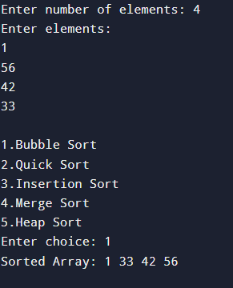
4)
#include <stdio.h>

int arr[100], n, i, key;

void linearSearch() {
int pos=-1;
for(i=0;i<n;i++) {
if(arr[i] == key) {
printf("Element found at position %d\n", i);
found = 0;
break;
}
}
if(found==-1)
printf("Element not found\n");
}

void binarySearch() {
int low=0,high=n-1,mid;
while(low <= high) {
mid =(low + high)/2;

if(arr[mid]==key) {
printf("Element found at position %d\n", mid + 1);
return;
}
else if(key<arr[mid])
high=mid-1;
else
low=mid+1;
}
printf("Element not found\n");
}

int main() {
int choice;

printf("Enter number of elements: ");
scanf("%d",&n);

printf("Enter elements:\n");
for(i=0; i<n;i++) {
scanf("%d",&arr[i]);
}

printf("Enter element to search: ");
scanf("%d", &key);

printf("\n1.Linear Seach\n");
printf("2.Binary Search:\n")
printf("Enter your choice: ");
scanf("%d", &choice);

switch(choice) {
case 1:
linearSearch();
break;
case 2:
binarySearch();
break;
default:
printf("Invalid choice\n");
}

return 0;
}
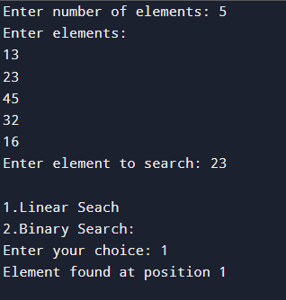

5)
#include <stdio.h>
#define MAX 5

int stack[MAX];
int top = -1;

void push() {
int value;
if (top==MAX-1) {
printf("Stack Overflow! Cannot push.\n");
} else {
printf("Enter value to push: ");
scanf("%d", &value);
top++;
stack[top]=value;
printf("%d pushed into stack.\n",value);
}
}

void pop() {
if (top==-1) {
printf("Stack Underflow! Cannot pop.\n");
} else {
printf("Popped element: %d\n",stack[top]);
top--;
}
}

void peek() {
if (top==-1) {
printf("Stack is empty.\n");
} else {
printf("Top element is: %d\n",stack[top]);
}
}

void display() {
if (top==-1) {
printf("Stack is empty.\n");
} else {
printf("Stack elements are:\n");
for (int i =top;i>= 0; i--) {
printf("%d\n",stack[i]);
}
}
}
int main() {
int choice;
do {
printf("\n--- STACK MENU ---\n");
printf("1. Push\n");
printf("2. Pop\n");
printf("3. Peek\n");
printf("4. Display\n");
printf("5. Exit\n");
printf("Enter your choice: ");
scanf("%d", &choice);

switch (choice) {
case 1:
push();
break;
case 2:
pop();
break;
case 3:
peek();
break;
case 4:
display();
break;
case 5:
printf("Exiting program...\n");
break;
default:
printf("Invalid choice!\n");
}

} while (choice != 5);
return 0;
}
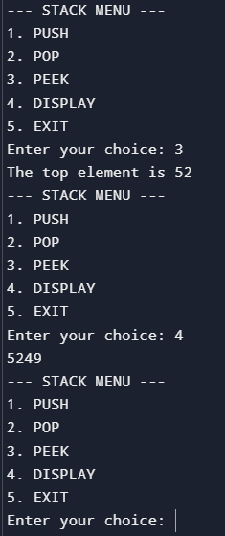

#include <stdio.h>
#define MAX 5

int q[MAX];
int front=-1,rear=-1;

void enqueue() {
int value;
if (rear==MAX-1) {
printf("Queue Overflow! Cannot insert.\n");
} else {
if(front==-1){
front=0;
}
printf("Enter value to insert: ");
scanf("%d", &value);
rear++;
q[rear]=value;
printf("%d inserted into queue\n",value);
}
}

void dequeue() {
if (front==-1||front>rear) {
printf("Underflow! Cannot delete.\n");
} else {
printf("Delete element: %d\n",q[front]);
front++;
}
}

void display() {
if (rear==-1||front>rear) {
printf("Queue is empty.\n");
} else {
printf("Queue elements are:\n");
for (int i =front;i<= rear; i++) {
printf("%d ",q[i]);
}
}
}
int main() {
int choice;
do {
printf("\n--- Queue MENU ---\n");
printf("1. Enqueue\n");
printf("2. Dequeue\n");
printf("3. Display\n");
printf("4. Exit\n");

printf("Enter your choice: ");
scanf("%d", &choice);

switch (choice) {
case 1:
enqueue();
break;
case 2:
dequeue();
break;
case 3:
display();
break;
case 4:
printf("Exiting program...\n");
break;
default:
printf("Invalid choice!\n");
}

} while (choice != 4);
return 0;
}

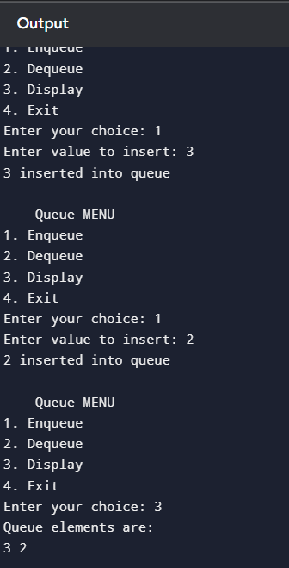
#include <stdio.h>
#define MAX 5

int queue[MAX];
int front=-1;
int rear=-1;

void enqueue() {
int value;

if ((rear+1)%MAX==front) {
printf("Queue Overflow! Cannot insert element.\n");
} else {
printf("Enter value to insert: ");
scanf("%d",&value);

if (front==-1) {
front=0;
rear=0;
} else {
rear=(rear+1)%MAX;
}

queue[rear]=value;
printf("%d inserted successfully.\n",value);
}
}

void dequeue() {
if (front==-1) {
printf("Queue Underflow!Queue is empty.\n");
} else {
printf("%d removed from queue.\n",queue[front]);

if (front==rear) {
front=-1;
rear=-1;
} else {
front=(front + 1)%MAX;
}
}
}

void display() {
int i;
if (front==-1) {
printf("Queue is empty.\n");
} else {
printf("Queue elements are:\n");
i=front;
while (1) {
printf("%d ", queue[i]);
if (i==rear)
break;
i =(i + 1) % MAX;
}
printf("\n");
}
}

int main() {
int choice;
do {
printf("\n---CIRCULAR QUEUE MENU---\n");
printf("1.Enqueue\n");
printf("2.Dequeue\n");
printf("3.Display\n");
printf("4.Exit\n");
printf("Enter your choice:");
scanf("%d", &choice);

switch(choice) {
case 1:
enqueue();
break;
case 2:
dequeue();
break;
case 3:
display();
break;
case 4:
printf("Exiting program.\n");
break;
default:
printf("Invalid choice! Try again.\n");
}
} while (choice!=4);

return 0;
}
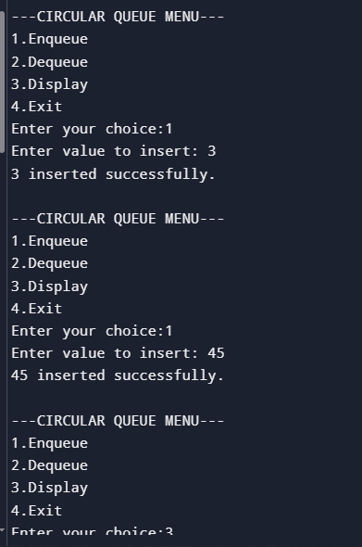
6)
#include <stdio.h>
#include <ctype.h>

int stack[100];
int top=-1;

void push(int x) {
stack++;
stack[top]=x;
}

int pop(){
return stack[top--];
}

int main() {
char exp[100];
int i = 0, a, b, result;

printf("Enter postfix expression: ");
scanf("%s", exp);

while (exp[i] != '\0') {
if (isdigit(exp[i])) {
push(exp[i] - '0');
} else {
b = pop();
a = pop();
switch (exp[i]) {
case '+': push(a + b); break;
case '-': push(a - b); break;
case '*': push(a * b); break;
case '/': push(a / b); break;
}
}
i++;
}

result = pop();
printf("Result = %d", result);

return 0;
}
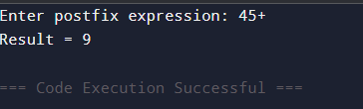

7)
#include <stdio.h>
#include <string.h>

char stack[100];
int top=-1;

void push(char x) {
stack++;
stack[top]=x;
}

char pop() {
return stack[top];
top--;
}

int previos(char x) {
if (x=='+' || x=='-') return 1;
if (x=='*' || x=='/') return 2;
return 0;
}

int main() {
char infix[100], postfix[100];
int i=0,j=0;

printf("Enter infix expression: ");
scanf("%s", infix);

while (infix[i] != '\0') {
if ((infix[i]>='a' && infix[i]<= 'z') ||
(infix[i]>='A' && infix[i]<= 'Z') ||
(infix[i]>='0' && infix[i]<= '9')) {
postfix[j++]=infix[i];
}
else if (infix[i] == '(') {
push(infix[i]);
}
else if (infix[i] == ')') {
while (stack[top] != '(')
postfix[j++] = pop();
pop();
}
else {
while (top != -1 && previous(stack[top]) >= previous(infix[i]))
postfix[j++] = pop();
push(infix[i]);
}
i++;
}

while (top!=-1)
postfix[j]=pop();
j++;

postfix[j] ='\0';

printf("Postfix expression: %s",postfix);

return 0;
}
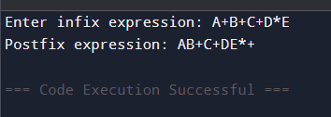
8)
// Online C compiler to run C program online
#include <stdio.h>
#include <stdlib.h>
struct node{
struct node *next;
int data;
};
struct node *head = NULL;
void insert(){
struct node *newnode;
newnode=(struct node*)malloc(sizeof(struct node));
printf("Enter value:");
scanf("%d",&newnode->data);
newnode->next=head;
head=newnode;
}
void display(){
struct node *temp;
temp=head;
while(temp!=NULL){
printf("%d->",temp->data);
temp=temp->next;
}
printf("List is empty\n");
}
void del(){
struct node *temp;
if(head==NULL){
printf("List is empty\n");
}
temp=head;
head=head->next;
free(temp);
}
int main() {
int ch;

do {
printf("----LINKED LIST MENU----\n 1.Insert\n 2.Delete\n 3.Display\n 4.Exit\n");
printf(" Enter choice: ");
scanf("%d",&ch);

switch(ch) {
case 1: insert();
break;
case 2: del();
break;
case 3: display();
break;
default:
printf("Invalid Choice.");
}
} while(ch != 4);

return 0;
}
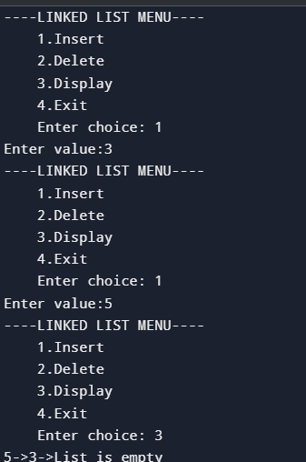
9)
#include <stdio.h>
#include <stdlib.h>

struct node {
int data;
struct node *next;
};

struct node *last=NULL;

void insert(){
struct node *newnode, *temp;
newnode = (struct node*)malloc(sizeof(struct node));

printf("Enter value:");
scanf("%d",&newnode->data);

if (last==NULL) {
last=newnode;
last->next=last;
} else {
newnode->next=last->next;
last->next=newnode;
last=newnode;
}
}

void delete(){
struct node *temp;

if (last==NULL) {
printf("List is empty\n");
return;
}

temp =last->next;

if (last->next==last) {
last=NULL;
free(temp);
} else {
last->next=temp->next;
free(temp);
}

printf("Node deleted\n");
}

void display(){
struct node *temp;

if (last==NULL){
printf("List is empty\n");
return;
}

temp=last->next;

do {
printf("%d -> ",temp->data);
temp = temp->next;
} while (temp!=last->next);

printf("(To start)\n");
}

int main() {
int choice;

while (1) {
printf("\n1. Insert\n2. Delete\n3. Display\n4. Exit\n");
printf("Enter choice: ");
scanf("%d", &choice);

switch (choice) {
case 1: insert(); break;
case 2: delete(); break;
case 3: display(); break;
case 4: exit(0);
default: printf("Invalid choice\n");
}
}

return 0;
}
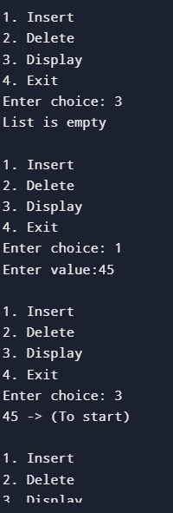

18)
// Online C compiler to run C program online
#include <string.h>
#include <stdio.h>
#define MAX 100
int front=-1,rear=-1;
char queue[MAX][40];

void enqueue(){
char name[40];
if(rear==MAX-1){
printf("The clinic is operating at full capacity.The list is full.\n");
}
printf("Enter the name of the patient:");
scanf("%s",name);
if (front==-1)
front=0;

rear++;
strcpy(queue[rear],name);
printf("Patient added successfully!\n");
printf("\n\n\n");

}
void peek() {
if (front==-1 ||front>rear) {
printf("No patients in queue.\n");

}

printf("Next patient to be treated: %s\n",queue[front]);
printf("\n\n\n");
}
void dequeue() {
if (front==-1 ||front>rear) {
printf("No patients to remove.\n");
}

printf("Patient %s has been treated and removed.\n", queue[front]);
printf("\n\n\n");
}
void display(){
if (front==-1 ||front>rear) {
printf("No patients to remove.\n");
}
for(int i=front;i<=rear;i++){
printf("%s\n",queue[i]);
}
printf("\n\n\n");
}

int main() {
int choice;

do{
printf("----Clinic Patient Management System----\n");
printf("1.Add a new patient\n");
printf("2.View the next patient\n");
printf("3.Remove a patient\n");
printf("4.View a list of all waiting patients\n");
printf("5.Exit\n");
printf("Enter your choice:");
scanf("%d",&choice);
switch (choice){
case 1:
enqueue();
break;
case 2:
peek();
break;
case 3:
dequeue();
break;
case 4:
display();
break;
case 5:
printf("Exiting the program....");
break;
default:
printf("Invalid choice!!");
break;
}
}while(choice!=5);

return 0;
}
